
SRM Institute of Science and Technology
Mode of Exam
OFFLINE
SET A

College of Engineering and Technology
DEPARTMENT OF ECE
SRM Nagar, Kattankulathur – 603203, Chengalpattu District, Tamilnadu
Academic Year: 2021-2022 (EVEN)
Batch 1
Test: CLAT-2 Date: 31/05/22
Course Code & Title: 18ECC202J / Linear Integrated Circuits Duration: 2 Periods
Year & Sem: II year / IV Sem Max. Marks: 50
Course Articulation Matrix:
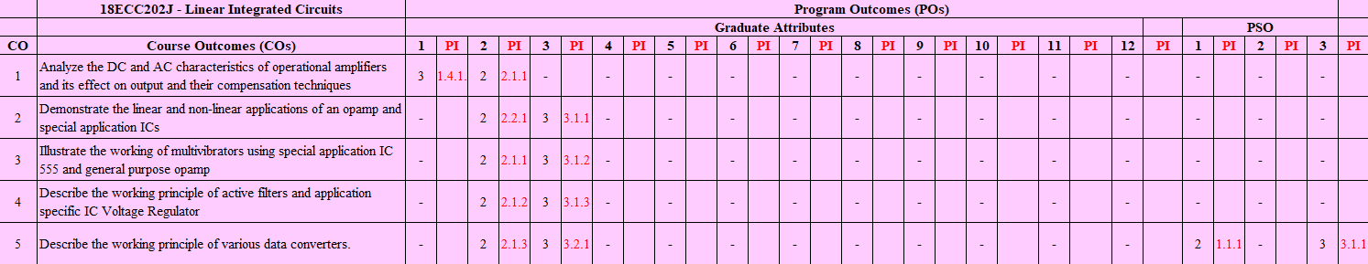

Part - A
(10 x 1 = 10 Marks)
Instructions: Answer ALL
Q. No | Question | Marks | BL | CO | PO | PI
1 | The ideal value of CMRR for an instrumentation amplifier is very high.  - True b. False | 1 | 1 | 2 | 2 | 2.2.1
2 | In Current to voltage converter, reduction of high frequency noise and possibility of oscillations are done by;  a. Resistor series with Capacitor in the input.  b. Resistor shunt with Capacitor in the input.  c. Resistor series with Capacitor in the feedback.  d. Resistor shunt with Capacitor in the feedback | 1 | 1 | 2 | 2 | 2.2.1
3 | The circuit used to add a predetermined dc level to the output voltage is called ……………….. | 1 | 1 | 2 | 2 | 2.2.1
4 | Which of the following relation is valid for the transconductance of an OTA?  a. g_{m}=I_{c}/2V_{T} b. 2I_{c}/V_{T} c. 2V_{T}/ I_{c} d. V_{T}/ 2I_{c} | 1 | 1 | 2 | 2 | 2.2.1
5 | Which of the following is not an application of a comparator?  a. Zero crossing detector b. Window detector  c. Frequency divider d. Time marker generator | 1 | 1 | 2 | 2 | 2.2.1
6 | A 555 timer in astable mode can be used to generate  a. PSK Signal b. ASK Signal c.FSK Signal d. OOK Signal | 1 | 1 | 3 | 2 | 2.1.1
7 | In the astable mode of operation of 555 timer, the capacitor voltage swings between  a. 1/3Vcc to 2/3Vcc b. 0.5Vcc to Vcc  c. +ꞵV_{sat} to -ꞵV_{sat} d. 0.25Vcc to 0.5Vcc | 1 | 1 | 3 | 2 | 2.1.1
8 | The pulse width of IC-555 monostable multivibrator for C=0.047uF and R=56KΩ is ……………………… | 1 | 1 | 3 | 2 | 2.1.1
9 | Which of the following module in PLL is responsible for the generation of sum and difference frequencies?  a. VCO b. LPF c. Error amplifier d. Phase detector | 1 | 1 | 3 | 2 | 2.1.1
10 | Calculate the value of capacitor of a Wein bridge oscillator, oscillating at a frequency of 1899 Hz and having R=2.89KΩ.  a. 2.29 µF b. 0.03 µF c.1.20 µF d. 3.90 µF | 1 | 3 | 3 | 2 | 2.1.1
Part – B
( 4 x 10 = 40 Marks)

SECTION B1
Instructions: Answer ANY 2 Questions
11 | For the circuit given below, if R₁=50KΩ; R₂ =10KΩ; R₃=25KΩ; R₄=40KΩ; R₅=10KΩ; R₆=30KΩ and V₁=V₂=2V; V₃=V₄=4V. Calculate the value of Vo.  .  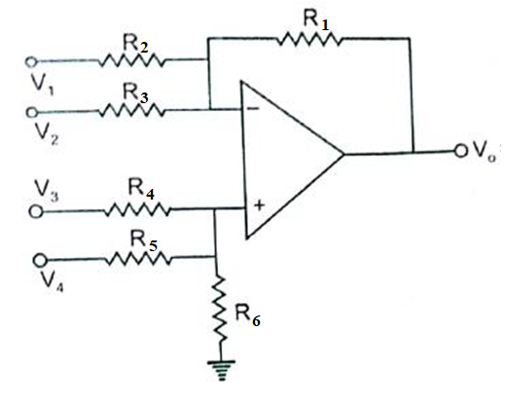 | 10 | 3 | 2 | 3 | 3.1.1
12 | With a neat circuit diagram, brief the working principle of op-amp based anti-log amplifier and derive the expression for the output voltage. | 10 | 3 | 2 | 2 | 2.2.1
13a | Draw the circuit diagram of sample and hold circuit using op-amp and explain its operation. | 4 | 2 | 2 | 2 | 2.2.1
13b | Identify and draw the op-amp based ciruit to perform the following operation.  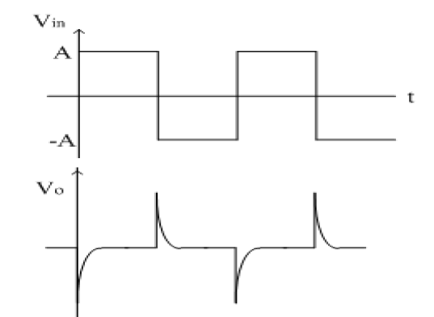  Justify by deriving the output expression of the circuit. | 6 | 4 | 2 | 3 | 3.1.1

SECTION B2
Instructions: Answer ANY 2 Questions
14 | With a neat circuit diagram, illustrate the operation of triangular wave generator using op-amp. | 10 | 3 | 3 | 2 | 2.1.1
15a | Draw the internal schematic of 555 timer IC and explain the principle of operation. | 8 | 3 | 3 | 2 | 2.1.1
15b | Design an op-amp based audio frequency oscillator using RC ladder network to generate a freqeuncy of 1KHz. | 2 | 3 | 3 | 3 | 3.1.2
16a | Design a practical astable multivibrator using op-amp (square wave generator) with the frequency f=25KHz. Assume R₁ = 1.16R₂ | 4 | 4 | 3 | 2 | 2.1.1
16b | Describe the operation of VCO with necessary circuit diagram and derive the expression for frequency of oscillation. | 6 | 2 | 3 | 2 | 2.1.1

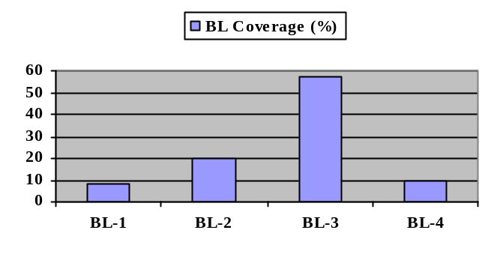Course Outcome (CO) and Bloom’s level (BL) Coverage in Questions
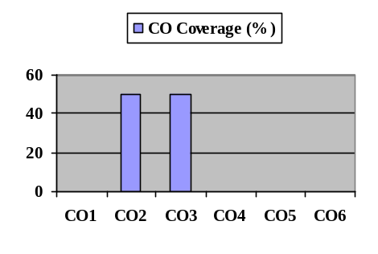

Approved by the Course Coordinator Signature of the Question paper setter

Evaluation Sheet
Name of the Student: Register No.:

Part- A (10 x 1= 10 Marks)
Q. No | CO | PO | Maximum Marks | Marks Obtained | Total
1 | CO2 | 2 | 1
2 | CO2 | 2 | 1
3 | CO2 | 2 | 1
4 | CO2 | 2 | 1
5 | CO2 | 2 | 1
6 | CO3 | 2 | 1
7 | CO3 | 2 | 1
8 | CO3 | 2 | 1
9 | CO3 | 2 | 1
10 | CO3 | 2 | 1
Part- B (4 x 10= 40 Marks)
11 | CO2 | 3 | 10
12 | CO2 | 2 | 10
13a | CO2 | 2 | 4
13b | CO2 | 3 | 6
14 | CO3 | 2 | 10
15a | CO3 | 2 | 8
15b | CO3 | 3 | 2
16a | CO3 | 2 | 4
16b | CO3 | 2 | 6

Consolidated Marks:

CO | Maximum Marks | Marks Obtained
2 | 35
3 | 35
Total

PO | Maximum Marks | Marks Obtained
2 | 52
3 | 18
Total

Signature of Course Teacher

Signature of the Course Coordinator Signature of the Academic Advisor

